PARENT WORLD, CONFIDENT TOGETHER
THE FAMILY ACTION WORKBOOK
A practical companion for Birth through Fifth Grade

From information to action
Use this workbook with the comprehensive guide to choose a small number of priorities, practice them at home, notice change, and know when to step forward, step back, or ask for help.

Connect. Practice. Notice. Adjust. Grow.

Start Here: How This Workbook Works
This is not a test
A child does not need to complete every page or meet every skill on the same timetable. Choose what matters now. The workbook is for planning and observation; it does not diagnose developmental, learning, medical, or mental-health conditions.

Step | Parent action
1. Notice | Choose one concrete skill or routine that is hard right now.
2. Find the prerequisite | Ask what earlier skill the current task depends on.
3. Model | Show one example and say what you are doing.
4. Do together | Share the task and give only the help needed.
5. Short independent try | Let the child attempt a fresh example.
6. Revisit | Practice briefly across several days and settings.
7. Decide | Advance, continue, simplify, or ask for professional/school support.

The Parent Support Ladder
Level | What it sounds like
Model | "Watch me do the first one."
Do together | "Let's do this one together."
Prompt | "What should you do first?"
Cue | Point to the checklist, tool, sound, model, or example.
Wait | Give the child time to retrieve or try.
Step back | Let the child own the task and check only afterward.

The Mastery Ladder
Stage | Meaning
Exposure | Has experienced the skill.
Emerging | Attempts with substantial help.
Competent | Can do it in a familiar situation with little help.
Independent | Can do it accurately/reliably without adult direction.
Generalized / Mastery | Can use it in a new setting, problem, book, routine, or project.

Family Learning Profile
Child name / nickname  ________________________________________________ | Current age or grade  ________________________________________________
School / program  ________________________________________________ | Date started  ________________________________________________
Family languages  ________________________________________________ | Important supports / accommodations  ________________________________________________
Strengths, interests, favorite topics, and what makes this child light up
What currently feels hard at home or school
What the child says would help
[ ] Best learning time: morning
[ ] Best learning time: after school
[ ] Best learning time: evening
[ ] Benefits from movement before sitting
[ ] Benefits from visual examples
[ ] Benefits from talking it out
[ ] Benefits from shorter sessions
[ ] Benefits from quiet / reduced distractions

Six-Week Family Learning Cycle

Choose only 1-2 priorities for this cycle
[ ] Development / communication
[ ] Reading / language
[ ] Writing / spelling
[ ] Math
[ ] Science / general knowledge
[ ] Organization / executive function
[ ] Social-emotional / self-advocacy
[ ] Physical / fine-motor / self-care
Primary priority  ________________________________________________ | Secondary priority  ________________________________________________
Cycle start date  ________________________________________________ | Review date  ________________________________________________
What would meaningful improvement look like?
Week | Plan
Week 1 | Baseline + model. Make the task easier enough for success.
Week 2 | Repeat the prerequisite skill in short sessions.
Week 3 | Use the skill in a second routine or context.
Week 4 | Reduce one level of adult help.
Week 5 | Try a slightly harder example or more independent version.
Week 6 | Review evidence; decide the next step and communicate if needed.
The activity/routine we will use most often

Weekly Home Learning Plan
Keep home from becoming a second school
Assigned homework can count as practice. On tired or busy days, choose connection, reading/conversation, and one small targeted skill instead of adding a long workload.

Day | 10-20 minute focus | Movement / play / break | What I noticed
Monday | ________________________ | ________________________ | ________________________
Tuesday | ________________________ | ________________________ | ________________________
Wednesday | ________________________ | ________________________ | ________________________
Thursday | ________________________ | ________________________ | ________________________
Friday | ________________________ | ________________________ | ________________________
Weekend | ________________________ | ________________________ | ________________________
[ ] Shared reading / conversation
[ ] Targeted skill practice
[ ] Movement / outdoor time
[ ] Chore / independence practice
[ ] Positive connection that had nothing to do with performance
One thing to celebrate this week

One-Page Family Progress Dashboard
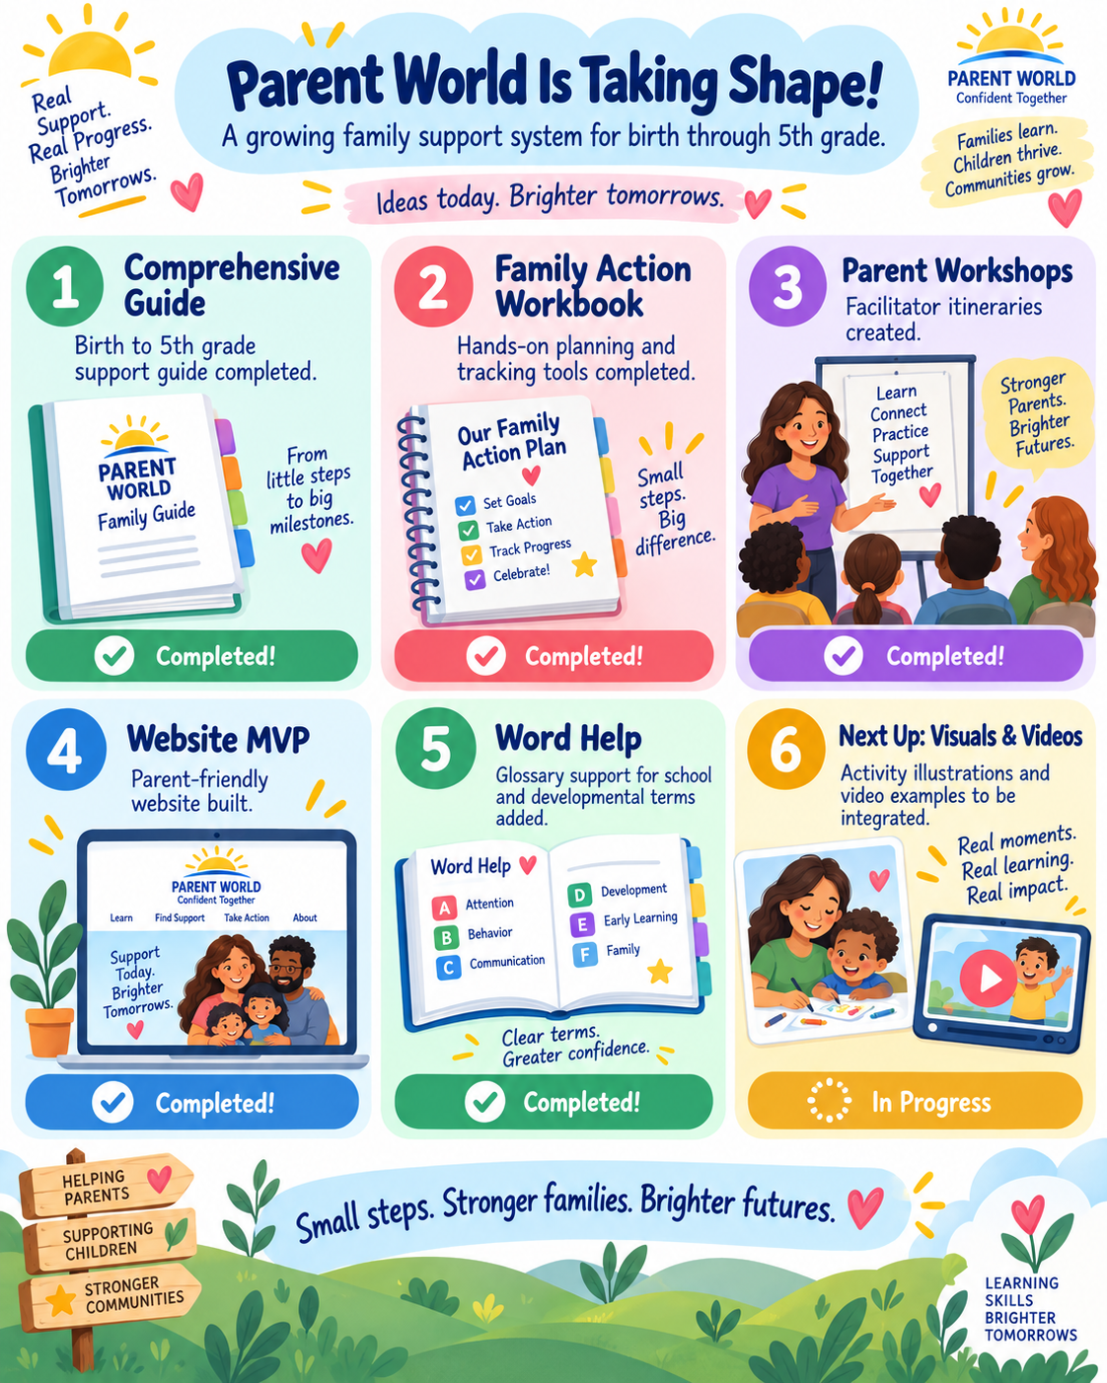
Progress milestone guide: an illustrated way to notice small wins and choose next steps.
Cycle dates  ________________________________________________ | Age / grade  ________________________________________________
Primary priority  ________________________________________________ | Secondary priority  ________________________________________________
Area | Strength now | Emerging / hard | Next small step
Language / reading
Writing / expression
Math / reasoning
Knowledge / curiosity
Independence / organization
Social-emotional well-being
Child voice: What feels easier? What still feels hard?
Parent decision: continue, advance, simplify, or ask for help?

School / Clinician Communication Log
Date | Person | Question / concern | Decision / next step
____________ | ____________ | ____________________________ | ____________________________
____________ | ____________ | ____________________________ | ____________________________
____________ | ____________ | ____________________________ | ____________________________
____________ | ____________ | ____________________________ | ____________________________
____________ | ____________ | ____________________________ | ____________________________
____________ | ____________ | ____________________________ | ____________________________
____________ | ____________ | ____________________________ | ____________________________
____________ | ____________ | ____________________________ | ____________________________
Patterns worth bringing to the next conversation

Birth to Three: Development Through Relationship and Play
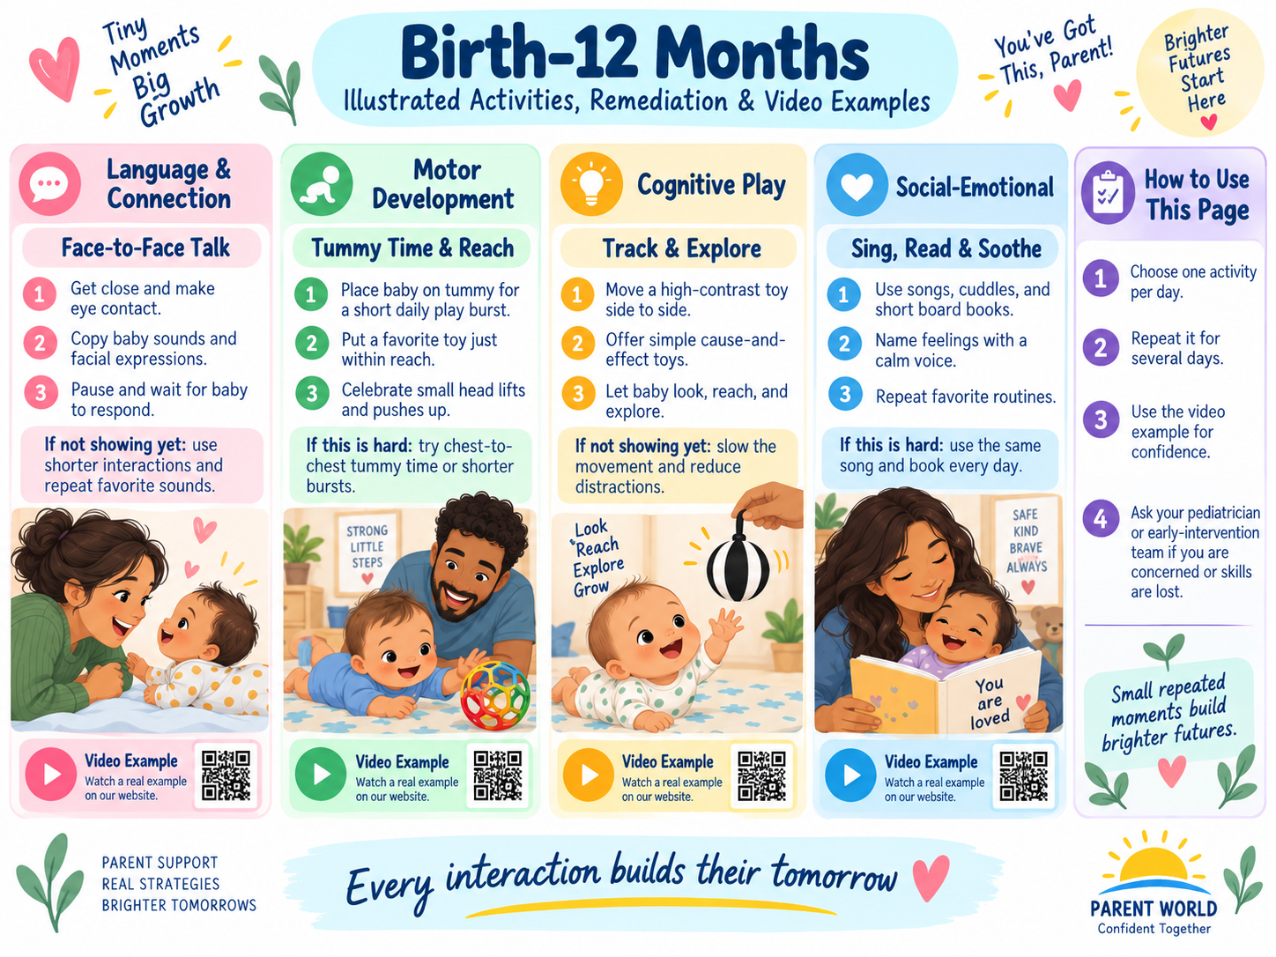
Birth–12 months: illustrated examples of simple home routines, activities, and remediation supports.
Parent job in this stage
Respond, talk, read, sing, move, play, and observe. Development is not perfectly linear. Use the checkpoint pages to notice patterns and provide practice, not to turn infancy into academic instruction.

[ ] I follow my child's attention more often than I redirect it.
[ ] I create safe opportunities to move and explore.
[ ] I pause so my child can respond in their own way.
[ ] I repeat useful routines without drilling.
[ ] I contact a healthcare professional promptly for regression or persistent concerns.

2 months: Family Practice Page
Stage focus
Connection, early sounds, attention to faces/voices, head and limb control

Choose only 1-2 priorities for this cycle
[ ] Social response / calming
[ ] Sounds beyond crying
[ ] Attention to faces / voices
[ ] Head lifting / symmetrical movement
Primary priority  ________________________________________________ | Secondary priority  ________________________________________________
Cycle start date  ________________________________________________ | Review date  ________________________________________________
What would meaningful improvement look like?

Baseline observation
What I see now - include a real example, not just "can/cannot"
[ ] I observed during a calm, familiar routine.
[ ] I considered sleep, hunger, illness, sensory load, and setting.
[ ] I looked for the skill on more than one day when appropriate.

2 months: Remediation and Progress

Remediation bridge: step back before pushing forward
Prerequisite to rebuild
birth to about 1 month: comfort with caregiver voice/face, brief alert attention, active limb movement. Rebuild short responsive exchanges and comfortable movement before asking for longer social turns or stronger head control.

Activity | What the parent does | What improvement may look like
Face-and-pause talk | Hold your baby comfortably about face distance away, smile or speak for a few seconds, then pause. Follow any look, sound, or body movement with another response. | More frequent orientation to your face/voice, relaxing, widening eyes, or beginning to smile back.
Voice from both sides | During calm awake time, speak softly from one side and then the other without startling or repeatedly testing. | Increasing orientation toward familiar voices or changes in expression when a voice begins.
Tummy-time micro-bursts | Use several short, supervised, awake tummy-time opportunities; chest-to-chest or a firm floor surface can make the position easier. Stop when the baby is fatigued. | Gradually longer head lifting and more comfortable pushing through the shoulders/forearms.
Hands-to-midline play | Bring a soft graspable toy to the center of the baby's body and let the hands contact it; gently help hands meet at midline if needed, without forcing a grip. | More open hands, hand-to-mouth movement, and brief voluntary contact with the object.
Research basis: CDC developmental monitoring plus Harvard serve-and-return: brief, contingent back-and-forth interaction and repeated safe movement opportunities support early communication and motor practice.
Do not wait on a real concern
If your baby is not meeting one or more milestones, does not respond to sounds/voices as expected, has unusual stiffness/floppiness, or loses a skill, contact the child's healthcare provider and ask about developmental screening.

Six-week progress tracker
Week | What we practiced | What I observed | Trend
Week 1 | ________________________________ | ________________________________ | [ ] easier [ ] same [ ] harder
Week 2 | ________________________________ | ________________________________ | [ ] easier [ ] same [ ] harder
Week 3 | ________________________________ | ________________________________ | [ ] easier [ ] same [ ] harder
Week 4 | ________________________________ | ________________________________ | [ ] easier [ ] same [ ] harder
Week 5 | ________________________________ | ________________________________ | [ ] easier [ ] same [ ] harder
Week 6 | ________________________________ | ________________________________ | [ ] easier [ ] same [ ] harder
Decision after six weeks: continue / advance / simplify / ask for help. Why?

4 months: Family Practice Page
Stage focus
Back-and-forth interaction, grasping, head control, early reaching

Choose only 1-2 priorities for this cycle
[ ] Social smiling / chuckles
[ ] Cooing / sound turns
[ ] Steady head / forearm push-up
[ ] Reach / grasp / hands to mouth
Primary priority  ________________________________________________ | Secondary priority  ________________________________________________
Cycle start date  ________________________________________________ | Review date  ________________________________________________
What would meaningful improvement look like?

Baseline observation
What I see now - include a real example, not just "can/cannot"
[ ] I observed during a calm, familiar routine.
[ ] I considered sleep, hunger, illness, sensory load, and setting.
[ ] I looked for the skill on more than one day when appropriate.

4 months: Remediation and Progress

Remediation bridge: step back before pushing forward
Prerequisite to rebuild
the 2-month checkpoint: social smiling/attention, sounds beyond crying, head lifting on tummy, active symmetrical movement. Return to face-to-face turn taking and supported upper-body control, then make the challenge only slightly harder.

Activity | What the parent does | What improvement may look like
Copy-the-coo | Copy one sound your baby makes, pause, and wait. Repeat only a few turns while the baby remains engaged. | More sound exchanges, chuckles, squeals, or attempts to answer your sound.
Reach-and-touch | Place one interesting safe toy at midline, then slightly to either side, close enough to contact with a small reach. | More purposeful swipes, touches, and eventually holding the toy placed in the hand.
Forearm push-up helper | During supervised tummy time, position yourself at eye level or place a toy ahead; a small rolled towel under the upper chest can be used briefly if the child tolerates it and an adult stays right there. | Steadier head control and more weight through forearms.
Hands-to-mouth discovery | Offer a clean, safe graspable object at midline and let the baby bring hands/object toward the mouth naturally. | More voluntary grasping, hand exploration, and coordinated hands-to-mouth movement.
Research basis: CDC milestone practice plus serve-and-return. The parent responds to the child's signal, repeats successful actions, and increases challenge gradually.
Do not wait on a real concern
Persistent concerns about head control, movement symmetry, hearing/vision response, social engagement, or loss of skills should be discussed with a healthcare provider rather than handled only through home practice.

Six-week progress tracker
Week | What we practiced | What I observed | Trend
Week 1 | ________________________________ | ________________________________ | [ ] easier [ ] same [ ] harder
Week 2 | ________________________________ | ________________________________ | [ ] easier [ ] same [ ] harder
Week 3 | ________________________________ | ________________________________ | [ ] easier [ ] same [ ] harder
Week 4 | ________________________________ | ________________________________ | [ ] easier [ ] same [ ] harder
Week 5 | ________________________________ | ________________________________ | [ ] easier [ ] same [ ] harder
Week 6 | ________________________________ | ________________________________ | [ ] easier [ ] same [ ] harder
Decision after six weeks: continue / advance / simplify / ask for help. Why?

6 months: Family Practice Page
Stage focus
Exploration, reciprocal sounds, rolling, supported sitting

Choose only 1-2 priorities for this cycle
[ ] Familiar people / social enjoyment
[ ] Sound turns / squeals
[ ] Reach and mouth exploration
[ ] Rolling / pushing / sitting support
Primary priority  ________________________________________________ | Secondary priority  ________________________________________________
Cycle start date  ________________________________________________ | Review date  ________________________________________________
What would meaningful improvement look like?

Baseline observation
What I see now - include a real example, not just "can/cannot"
[ ] I observed during a calm, familiar routine.
[ ] I considered sleep, hunger, illness, sensory load, and setting.
[ ] I looked for the skill on more than one day when appropriate.

6 months: Remediation and Progress

Remediation bridge: step back before pushing forward
Prerequisite to rebuild
the 4-month checkpoint: reciprocal sounds, steady head control, grasping, forearm push-up, hands-to-mouth exploration. Rebuild reciprocal communication, trunk/shoulder control, and purposeful reaching before expecting more independent sitting and object exploration.

Activity | What the parent does | What improvement may look like
Sound ladder | Copy a familiar sound, then add one small variation such as a longer vowel, squeal, or raspberry; pause for a response. | The child attempts a wider range of sounds and takes more vocal turns.
Roll-and-reach | From a comfortable floor position, place a toy slightly to the side so the child has a reason to turn the head, reach across, or roll. Do not pull the child by an arm or leg. | More intentional side-to-side movement and attempts to roll toward the object.
Supported sit-and-reach | Sit on the floor with the child supported securely at the trunk/hips; place a toy at easy reach and let the child return to upright with your help. | More trunk control and less adult support needed for brief sitting/reaching.
One object, many actions | Offer one safe object and model touch, mouth, shake, and pass hand-to-hand. Let the child choose which action to repeat. | Longer exploration and beginning transfer between hands.
Research basis: CDC milestones, responsive interaction, and graded practice: keep the challenge just above what the child can already do.
Do not wait on a real concern
If movement, sitting control, use of both sides of the body, response to sound, social interaction, or skill loss concerns you, act early and discuss it with the child's clinician.

Six-week progress tracker
Week | What we practiced | What I observed | Trend
Week 1 | ________________________________ | ________________________________ | [ ] easier [ ] same [ ] harder
Week 2 | ________________________________ | ________________________________ | [ ] easier [ ] same [ ] harder
Week 3 | ________________________________ | ________________________________ | [ ] easier [ ] same [ ] harder
Week 4 | ________________________________ | ________________________________ | [ ] easier [ ] same [ ] harder
Week 5 | ________________________________ | ________________________________ | [ ] easier [ ] same [ ] harder
Week 6 | ________________________________ | ________________________________ | [ ] easier [ ] same [ ] harder
Decision after six weeks: continue / advance / simplify / ask for help. Why?

9 months: Family Practice Page
Stage focus
Sitting, name response, gestures, object permanence, babbling

Choose only 1-2 priorities for this cycle
[ ] Response to name
[ ] Varied babbling / gestures
[ ] Search for hidden or dropped objects
[ ] Independent sitting / hand transfer
Primary priority  ________________________________________________ | Secondary priority  ________________________________________________
Cycle start date  ________________________________________________ | Review date  ________________________________________________
What would meaningful improvement look like?

Baseline observation
What I see now - include a real example, not just "can/cannot"
[ ] I observed during a calm, familiar routine.
[ ] I considered sleep, hunger, illness, sensory load, and setting.
[ ] I looked for the skill on more than one day when appropriate.

9 months: Remediation and Progress

Remediation bridge: step back before pushing forward
Prerequisite to rebuild
the 6-month checkpoint: reciprocal sounds, object reaching/exploration, rolling, supported sitting and pushing through the arms. Strengthen sitting, object transfer, name/voice attention, and simple social games before asking for more complex gestures and purposeful problem solving.

Activity | What the parent does | What improvement may look like
Name-pause-connect | Say the child's name once during calm play, pause, and warmly respond to any turn of the head, eyes, or body. Avoid rapid repeated calling. | More consistent orientation to name/voice during everyday interaction.
Peekaboo with an object | Partly hide a favorite toy under a cloth, then gradually hide more as the child begins to search. | Reaching or looking for an object that is partly or fully hidden.
Sit-transfer basket | While the child sits safely, offer two large safe objects and a low container; model moving an object hand-to-hand and dropping it in. | More stable sitting, hand transfer, banging, and purposeful release.
Gesture routine | Pair one gesture with the same word in a natural routine - arms up for "up," waving for "bye," clapping for "yay." | The child begins anticipating or copying the gesture and using it intentionally.
Research basis: CDC milestones and Harvard serve-and-return: pair simple language with the child's attention and repeat functional routines.
Do not wait on a real concern
If the child does not sit independently, rarely responds to name/voice, is not babbling/gesturing, or loses skills, contact the pediatrician and ask about developmental screening.

Six-week progress tracker
Week | What we practiced | What I observed | Trend
Week 1 | ________________________________ | ________________________________ | [ ] easier [ ] same [ ] harder
Week 2 | ________________________________ | ________________________________ | [ ] easier [ ] same [ ] harder
Week 3 | ________________________________ | ________________________________ | [ ] easier [ ] same [ ] harder
Week 4 | ________________________________ | ________________________________ | [ ] easier [ ] same [ ] harder
Week 5 | ________________________________ | ________________________________ | [ ] easier [ ] same [ ] harder
Week 6 | ________________________________ | ________________________________ | [ ] easier [ ] same [ ] harder
Decision after six weeks: continue / advance / simplify / ask for help. Why?

12 months: Family Practice Page
Stage focus
Intentional communication, containers, pincer grasp, supported mobility

Choose only 1-2 priorities for this cycle
[ ] Gestures / early words
[ ] Interactive games
[ ] In-out / imitation
[ ] Pull to stand / cruise / pincer grasp
Primary priority  ________________________________________________ | Secondary priority  ________________________________________________
Cycle start date  ________________________________________________ | Review date  ________________________________________________
What would meaningful improvement look like?

Baseline observation
What I see now - include a real example, not just "can/cannot"
[ ] I observed during a calm, familiar routine.
[ ] I considered sleep, hunger, illness, sensory load, and setting.
[ ] I looked for the skill on more than one day when appropriate.

12 months: Remediation and Progress

Remediation bridge: step back before pushing forward
Prerequisite to rebuild
the 9-month checkpoint: sitting without support, object transfer, varied babbling, response to name, searching for dropped/hidden objects. Rebuild intentional gestures, simple cause-and-effect play, hand use, and supported mobility before expecting more words and independent object use.

Activity | What the parent does | What improvement may look like
Gesture + word choice | Offer two familiar items, name them, and wait for a look, reach, point, or sound; honor the choice and say the word again. | More intentional requesting and shared attention.
In-out container play | Model putting one object into a container and taking it out. Pause so the child can copy before adding more pieces. | Purposeful release into a container and repeated problem solving.
Stand-and-cruise invitation | At a stable, child-safe surface and with close supervision, place a desired toy a short distance away so the child can pull to stand or move sideways if ready. Never force standing/walking. | More confident weight bearing, pulling to stand, or cruising attempts.
Pincer practice at meals | Offer developmentally safe, soft bite-size pieces on a clean tray and allow the child to pick them up while seated and supervised. | Increasing thumb-and-finger pickup and controlled release.
Research basis: CDC milestones; parent scaffolding uses a clear model, a short wait, and functional repetition inside normal routines.
Do not wait on a real concern
If the child is not using gestures, not attempting mobility in any form, has feeding/hand-use concerns, or loses skills, talk with the child's healthcare provider promptly.

Six-week progress tracker
Week | What we practiced | What I observed | Trend
Week 1 | ________________________________ | ________________________________ | [ ] easier [ ] same [ ] harder
Week 2 | ________________________________ | ________________________________ | [ ] easier [ ] same [ ] harder
Week 3 | ________________________________ | ________________________________ | [ ] easier [ ] same [ ] harder
Week 4 | ________________________________ | ________________________________ | [ ] easier [ ] same [ ] harder
Week 5 | ________________________________ | ________________________________ | [ ] easier [ ] same [ ] harder
Week 6 | ________________________________ | ________________________________ | [ ] easier [ ] same [ ] harder
Decision after six weeks: continue / advance / simplify / ask for help. Why?

15 months: Family Practice Page
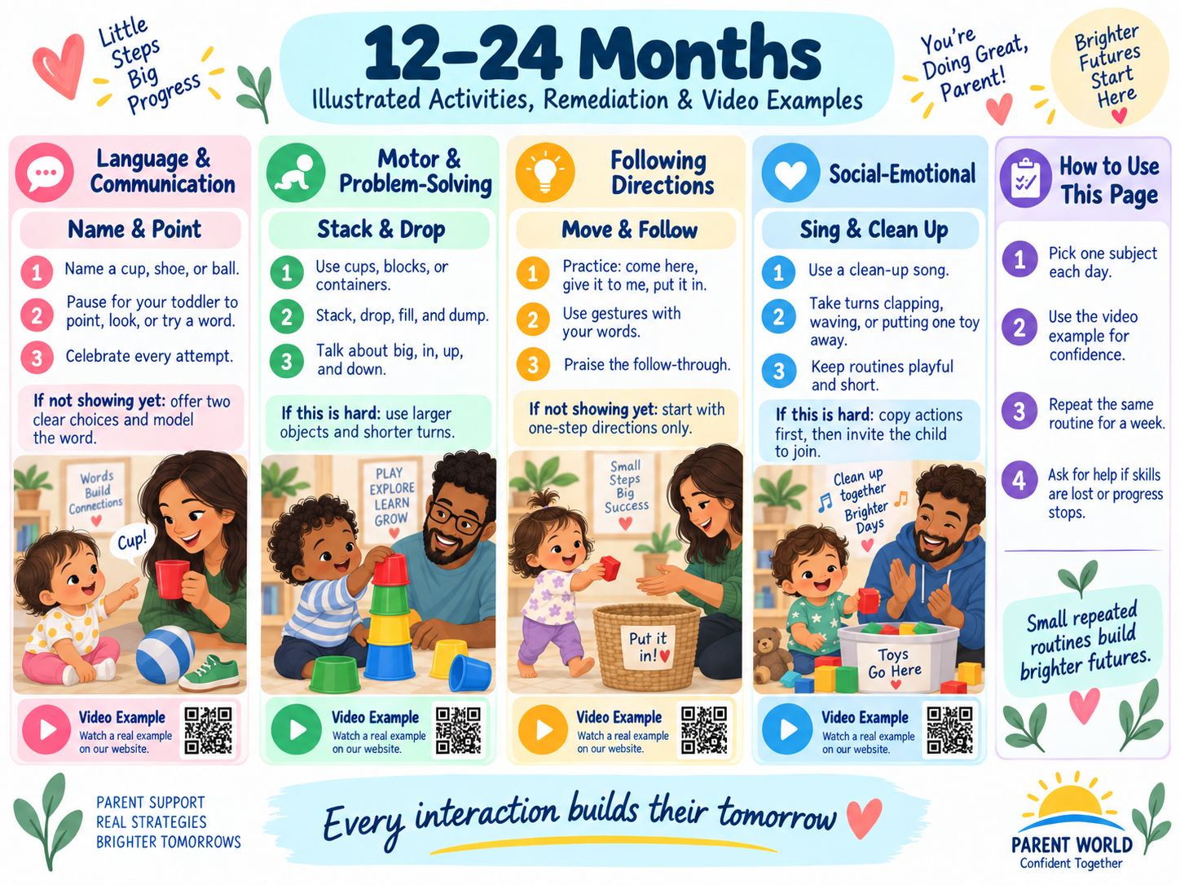
12–24 months: illustrated examples of toddler activities and remediation supports.
Stage focus
Pointing, early words, object use, first independent steps

Choose only 1-2 priorities for this cycle
[ ] Shows / points to objects
[ ] 1-2 words beyond caregiver names
[ ] Simple directions / object use
[ ] Steps / finger feeding
Primary priority  ________________________________________________ | Secondary priority  ________________________________________________
Cycle start date  ________________________________________________ | Review date  ________________________________________________
What would meaningful improvement look like?

Baseline observation
What I see now - include a real example, not just "can/cannot"
[ ] I observed during a calm, familiar routine.
[ ] I considered sleep, hunger, illness, sensory load, and setting.
[ ] I looked for the skill on more than one day when appropriate.

15 months: Remediation and Progress

Remediation bridge: step back before pushing forward
Prerequisite to rebuild
the 12-month checkpoint: interactive games, waving/gestures, putting objects into containers, pulling to stand/cruising, thumb-and-finger pickup. Return to purposeful gestures, imitation, functional object use, and supported walking practice before layering on more vocabulary and independence.

Activity | What the parent does | What improvement may look like
Point-name-wait | When the child looks or reaches toward something, point too, name it once, then wait. If the child makes any sound/gesture, respond as communication. | More pointing/showing, attempts at words, and shared attention.
One-step direction with fade | Start with a simple request plus gesture - "give me the cup." After success, use the same request with a smaller gesture, then just words. | Following familiar one-step directions with less visual help.
Copy a real-life action | Model brushing a doll's hair, stirring with a spoon, rolling a toy car, or wiping a table; hand the object to the child. | More functional use of familiar objects and imitation.
Walk, stop, carry | Create a very short safe route between two adults or stable supports; add carrying a light object only after walking is comfortable. | More independent steps, balance, and purposeful movement.
Research basis: CDC milestones and responsive scaffolding. Fade prompts rather than repeating the same full prompt indefinitely.
Do not wait on a real concern
At the 15-month checkpoint, persistent concerns about language/gestures, social communication, object use, walking, feeding, or play should be discussed with the pediatrician. Do not wait for the 18-month visit if you are concerned.

Six-week progress tracker
Week | What we practiced | What I observed | Trend
Week 1 | ________________________________ | ________________________________ | [ ] easier [ ] same [ ] harder
Week 2 | ________________________________ | ________________________________ | [ ] easier [ ] same [ ] harder
Week 3 | ________________________________ | ________________________________ | [ ] easier [ ] same [ ] harder
Week 4 | ________________________________ | ________________________________ | [ ] easier [ ] same [ ] harder
Week 5 | ________________________________ | ________________________________ | [ ] easier [ ] same [ ] harder
Week 6 | ________________________________ | ________________________________ | [ ] easier [ ] same [ ] harder
Decision after six weeks: continue / advance / simplify / ask for help. Why?

18 months: Family Practice Page
Stage focus
Language growth, pretend play, walking, scribbling, self-help

Choose only 1-2 priorities for this cycle
[ ] 3+ words beyond caregiver names
[ ] One-step directions
[ ] Simple pretend / chore imitation
[ ] Walking / scribbling / spoon / cup
Primary priority  ________________________________________________ | Secondary priority  ________________________________________________
Cycle start date  ________________________________________________ | Review date  ________________________________________________
What would meaningful improvement look like?

Baseline observation
What I see now - include a real example, not just "can/cannot"
[ ] I observed during a calm, familiar routine.
[ ] I considered sleep, hunger, illness, sensory load, and setting.
[ ] I looked for the skill on more than one day when appropriate.

18 months: Remediation and Progress

Remediation bridge: step back before pushing forward
Prerequisite to rebuild
the 15-month checkpoint: pointing to ask/show, a few words, simple directions, functional object use, a few independent steps. Rebuild single-word/gesture communication, one-step directions, simple pretend action, and basic self-help before expecting more complex phrases and sequences.

Activity | What the parent does | What improvement may look like
One word -> two | When the child uses a word or gesture, add one useful word: "truck" -> "truck go," "more" -> "more milk." Do not require repetition every time. | More spontaneous two-part messages and increased useful vocabulary.
Pretend chore copy | Do one familiar action together - wipe the table, put laundry in a basket, feed a doll - then pause for the child to continue. | Imitation of familiar routines and beginning pretend play.
Scribble station | Tape large paper securely to a table, offer chunky crayons, and model a few marks; let the child explore without requiring a picture. | More intentional scribbling and comfortable grasp/release.
Self-help mini-step | Practice one part of an everyday routine: carry cup to table, put arms through sleeves, scoop a thick food with a spoon, or wash hands with help. | Increasing participation with fewer adult hand-over-hand prompts.
Research basis: CDC milestones; Harvard serve-and-return; frequent, functional language models are more useful than repeated testing.
Do not wait on a real concern
If the child has very limited intentional communication, is not walking independently, does not imitate simple actions, or loses skills, discuss it with the pediatrician and early-intervention program.

Six-week progress tracker
Week | What we practiced | What I observed | Trend
Week 1 | ________________________________ | ________________________________ | [ ] easier [ ] same [ ] harder
Week 2 | ________________________________ | ________________________________ | [ ] easier [ ] same [ ] harder
Week 3 | ________________________________ | ________________________________ | [ ] easier [ ] same [ ] harder
Week 4 | ________________________________ | ________________________________ | [ ] easier [ ] same [ ] harder
Week 5 | ________________________________ | ________________________________ | [ ] easier [ ] same [ ] harder
Week 6 | ________________________________ | ________________________________ | [ ] easier [ ] same [ ] harder
Decision after six weeks: continue / advance / simplify / ask for help. Why?

24 months: Family Practice Page
Stage focus
Two-word language, symbolic play, empathy, running and stairs

Choose only 1-2 priorities for this cycle
[ ] Two-word combinations
[ ] Points in books / body parts
[ ] Combines toys in play
[ ] Run / kick / stairs / spoon
Primary priority  ________________________________________________ | Secondary priority  ________________________________________________
Cycle start date  ________________________________________________ | Review date  ________________________________________________
What would meaningful improvement look like?

Baseline observation
What I see now - include a real example, not just "can/cannot"
[ ] I observed during a calm, familiar routine.
[ ] I considered sleep, hunger, illness, sensory load, and setting.
[ ] I looked for the skill on more than one day when appropriate.

24 months: Remediation and Progress

Remediation bridge: step back before pushing forward
Prerequisite to rebuild
the 18-month checkpoint: at least a few words, one-step directions, simple pretend/chores, independent walking, scribbling, beginning utensil use. Strengthen simple phrases, symbolic play, purposeful movement, and two-part routines before expecting longer directions or more elaborate pretend play.

Activity | What the parent does | What improvement may look like
Phrase builder during play | Model short useful combinations tied to action: "bear sleeps," "car goes," "want red." Pause and respond to any attempt. | More two-word combinations, especially noun+action or request phrases.
Book point-and-find | In a familiar picture book, ask for one item ("Where is the dog?"), then one body part on self/doll. Help with pointing if needed and keep it playful. | More consistent pointing to named pictures/body parts and sustained shared book attention.
Two-toy story | Use two related toys - doll+spoon, car+garage, animal+bed - and model one simple relationship, then let the child repeat or change it. | Coordinating two toys in purposeful or pretend play.
Move-and-follow route | Use a simple safe route: run to a marker, kick/roll a ball, step up one low stair with support as needed, then return. | More coordinated running, kicking/rolling, and participation in a short movement sequence.
Research basis: CDC 2-year milestones; play-based language expansion and functional routines preserve meaning while increasing complexity.
Do not wait on a real concern
If two-word communication is not emerging, the child has major difficulty understanding everyday language, or motor/social skills are concerning, ask the pediatrician and school/early-intervention team about screening and support.

Six-week progress tracker
Week | What we practiced | What I observed | Trend
Week 1 | ________________________________ | ________________________________ | [ ] easier [ ] same [ ] harder
Week 2 | ________________________________ | ________________________________ | [ ] easier [ ] same [ ] harder
Week 3 | ________________________________ | ________________________________ | [ ] easier [ ] same [ ] harder
Week 4 | ________________________________ | ________________________________ | [ ] easier [ ] same [ ] harder
Week 5 | ________________________________ | ________________________________ | [ ] easier [ ] same [ ] harder
Week 6 | ________________________________ | ________________________________ | [ ] easier [ ] same [ ] harder
Decision after six weeks: continue / advance / simplify / ask for help. Why?

30 months: Family Practice Page
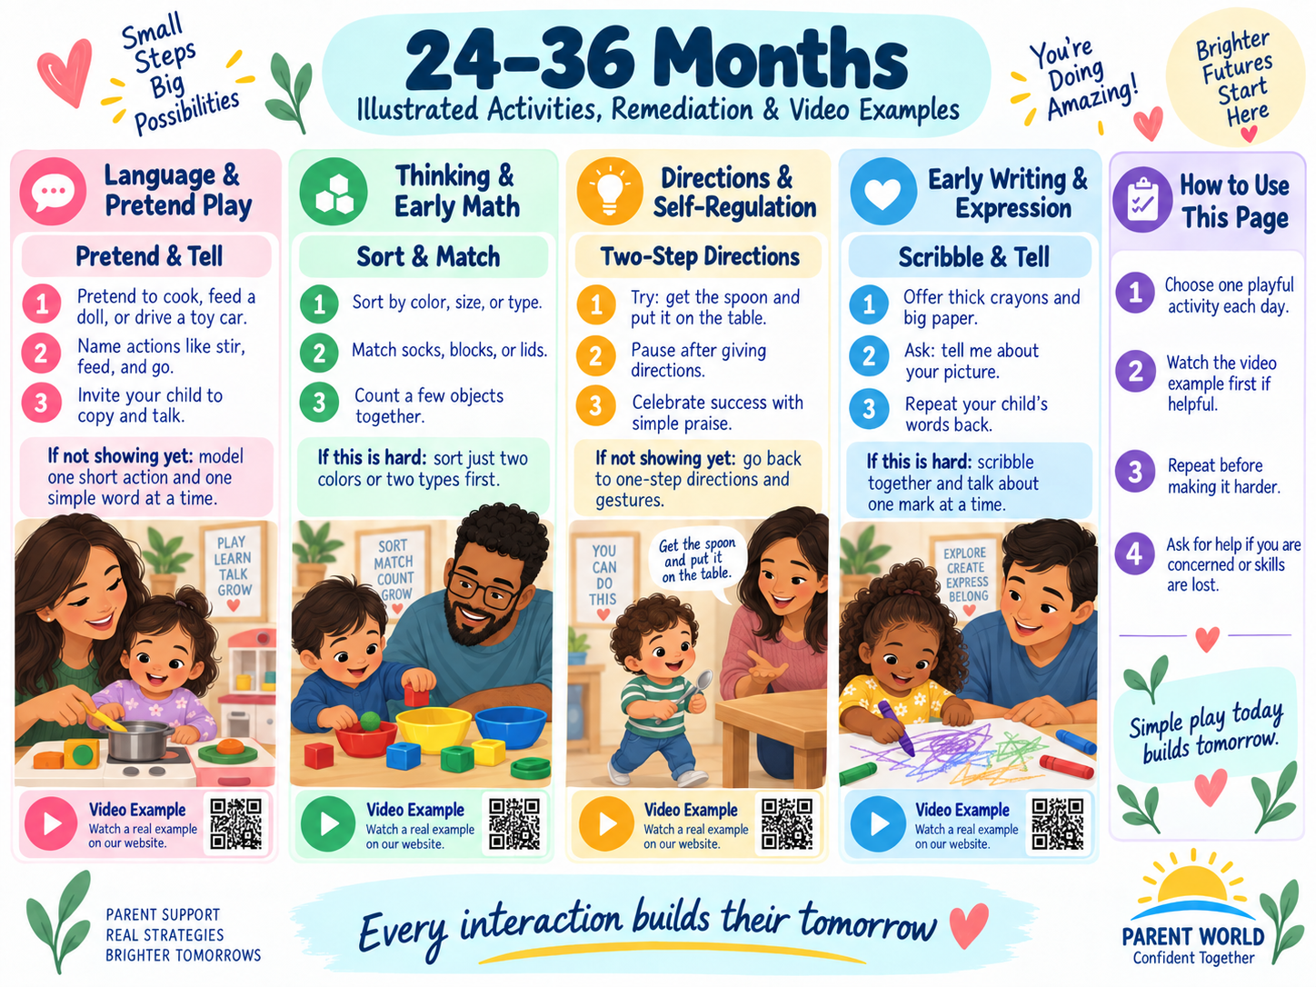
24–36 months: illustrated examples of activities that build readiness through play and routine.
Stage focus
Vocabulary, routines, pretend play, two-step directions, jumping

Choose only 1-2 priorities for this cycle
[ ] About 50 words / action phrases
[ ] Simple routines and peer play
[ ] Pretend and two-step directions
[ ] Jumping / page turning / clothing
Primary priority  ________________________________________________ | Secondary priority  ________________________________________________
Cycle start date  ________________________________________________ | Review date  ________________________________________________
What would meaningful improvement look like?

Baseline observation
What I see now - include a real example, not just "can/cannot"
[ ] I observed during a calm, familiar routine.
[ ] I considered sleep, hunger, illness, sensory load, and setting.
[ ] I looked for the skill on more than one day when appropriate.

30 months: Remediation and Progress

Remediation bridge: step back before pushing forward
Prerequisite to rebuild
the 24-month checkpoint: two-word phrases, pointing in books, simple two-object play, running/kicking, spoon use, early concern for others. Rebuild action phrases, two-step routines, symbolic play, basic classification, and self-help before expecting longer conversation and more independent routines.

Activity | What the parent does | What improvement may look like
Two-step helper job | Give two concrete linked steps: "get the napkin and put it on the table." Start by doing the first step together, then fade help. | Completing both parts with fewer reminders.
Pretend sequence | Model a 2-3 step story such as feed doll -> wipe mouth -> put doll to bed. Let the child copy, reorder, or add a step. | Longer pretend sequences and better memory for order.
Color/shape match first | Use two obvious categories (red/blue lids, big/small blocks, circle/square). Match rather than quiz; name the property while sorting. | Consistent matching and beginning naming/classification.
Jump-turn-page-dress practice | Choose one motor/self-help skill at a time: two-foot jump, turning one page, removing a loose garment, or putting an arm through a sleeve. Model, assist lightly, then wait. | Increasing control and less physical prompting.
Research basis: CDC 30-month milestones; IES early-childhood guidance supports developmental progressions and building from what a child already knows.
Do not wait on a real concern
If language, pretend play, social engagement, movement, or self-help concerns persist, or a skill is lost, talk with the child's healthcare provider and the local early-childhood/public-school evaluation system.

Six-week progress tracker
Week | What we practiced | What I observed | Trend
Week 1 | ________________________________ | ________________________________ | [ ] easier [ ] same [ ] harder
Week 2 | ________________________________ | ________________________________ | [ ] easier [ ] same [ ] harder
Week 3 | ________________________________ | ________________________________ | [ ] easier [ ] same [ ] harder
Week 4 | ________________________________ | ________________________________ | [ ] easier [ ] same [ ] harder
Week 5 | ________________________________ | ________________________________ | [ ] easier [ ] same [ ] harder
Week 6 | ________________________________ | ________________________________ | [ ] easier [ ] same [ ] harder
Decision after six weeks: continue / advance / simplify / ask for help. Why?

36 months: Family Practice Page
Stage focus
Conversation, questions, peer play, simple drawing and self-care

Choose only 1-2 priorities for this cycle
[ ] Back-and-forth conversation
[ ] Who/what/where/why questions
[ ] Joins other children / short separation
[ ] Circle / dressing / fork use
Primary priority  ________________________________________________ | Secondary priority  ________________________________________________
Cycle start date  ________________________________________________ | Review date  ________________________________________________
What would meaningful improvement look like?

Baseline observation
What I see now - include a real example, not just "can/cannot"
[ ] I observed during a calm, familiar routine.
[ ] I considered sleep, hunger, illness, sensory load, and setting.
[ ] I looked for the skill on more than one day when appropriate.

36 months: Remediation and Progress

Remediation bridge: step back before pushing forward
Prerequisite to rebuild
the 30-month checkpoint: two-step directions, short action phrases, pretend sequences, basic matching/classification, jumping and increasing self-help. Before expecting preschool-like conversation, peer participation, and independent self-help, strengthen short conversation turns, question understanding, drawing imitation, and supported social routines.

Activity | What the parent does | What improvement may look like
Picture conversation | Choose one family photo or book picture. Adult comments once, asks one simple question, waits, and responds to the child's answer with one added detail. | At least two back-and-forth exchanges about the same topic.
Who/what/where game | Use familiar people and routines: "Who is eating?" "What is Dad doing?" "Where is the shoe?" Offer two choices if the child is stuck. | More accurate answers to simple WH questions and action descriptions.
Copy a circle, then decorate | Adult draws a slow circle; child copies on large paper. If needed, trace a large circular object together first. | A more closed circular form and greater control, not perfect handwriting.
Turn-taking + self-help rehearsal | Roll a ball or take turns adding blocks while practicing "my turn/your turn," then finish with one self-help step such as fork use or putting on a loose jacket. | Waiting briefly for a turn and completing a familiar self-help action with less help.
Research basis: CDC 3-year milestones; Harvard executive-function activities emphasize age-appropriate rule games, imitation, and gradually reduced adult support.
Do not wait on a real concern
CDC advises acting early when a milestone is missing or a parent has concerns. Loss of skills, persistent communication/social concerns, or substantial motor/self-help difficulty warrants professional discussion rather than only home practice.

Six-week progress tracker
Week | What we practiced | What I observed | Trend
Week 1 | ________________________________ | ________________________________ | [ ] easier [ ] same [ ] harder
Week 2 | ________________________________ | ________________________________ | [ ] easier [ ] same [ ] harder
Week 3 | ________________________________ | ________________________________ | [ ] easier [ ] same [ ] harder
Week 4 | ________________________________ | ________________________________ | [ ] easier [ ] same [ ] harder
Week 5 | ________________________________ | ________________________________ | [ ] easier [ ] same [ ] harder
Week 6 | ________________________________ | ________________________________ | [ ] easier [ ] same [ ] harder
Decision after six weeks: continue / advance / simplify / ask for help. Why?

Preschool / Pre-K: Playful Foundations for School
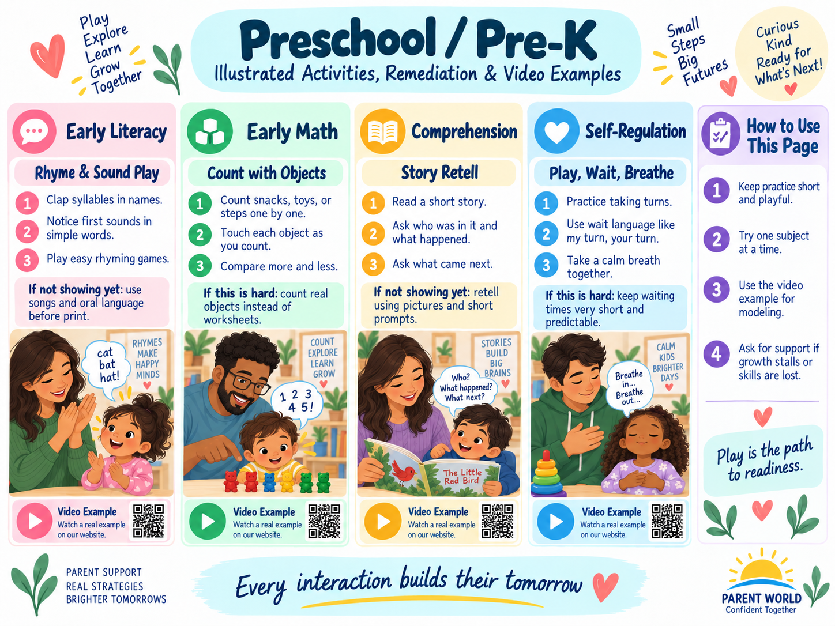
Preschool / Pre-K: visual activity and remediation examples for play, language, self-regulation, and early academics.
Keep it playful
Build oral language, sound awareness, counting, early writing, self-help, and social routines through books, pretend play, art, movement, household jobs, and short games. Worksheets are optional, not the foundation.

Choose only 1-2 priorities for this cycle
[ ] Conversation / storytelling
[ ] Sound awareness / rhymes
[ ] Counting / quantity
[ ] Drawing / emergent writing
[ ] Pretend play / flexible thinking
[ ] Self-help / routines
[ ] Joining play / turn-taking
Primary priority  ________________________________________________ | Secondary priority  ________________________________________________
Cycle start date  ________________________________________________ | Review date  ________________________________________________
What would meaningful improvement look like?
What my child loves to play, talk, build, draw, or pretend

Preschool Weekly Play Plan
Day | Language / book | Math / sorting / building | Movement / social / self-help
Mon | ________________ | ________________ | ________________
Tue | ________________ | ________________ | ________________
Wed | ________________ | ________________ | ________________
Thu | ________________ | ________________ | ________________
Fri | ________________ | ________________ | ________________
Weekend | ________________ | ________________ | ________________
[ ] Read/talk most days
[ ] Free pretend play
[ ] Outdoor movement
[ ] Count/sort real objects
[ ] Draw/paint/build
[ ] Practice one self-help routine
[ ] Peer or family turn-taking opportunity
A new word, idea, or story my child used this week

Preschool Remediation Bridge

Remediation bridge: step back before pushing forward
Prerequisite to rebuild
the 30-36 month foundations: short conversations, simple pretend sequences, matching/classifying, two-step routines, increasing self-help and turn-taking. Step back to concrete play, oral language, small quantities, and short routines before adding worksheets or abstract symbols.

Activity | What the parent does | What improvement may look like
Conversation replay | Use a familiar photo/book. Ask "what happened?" and help the child answer with who + action + one detail; act it out with toys if words are hard. | A short understandable message and increasing ability to stay on one topic.
Sound-and-rhyme play | Play "same beginning sound" or rhyme with names and familiar objects; for a child not ready for rhyme, simply notice and repeat the first sound together. | The child begins noticing sound similarities without needing to name formal rules.
Count what you touch | Count 1-5 real objects by moving/touching each one once, then ask for a small quantity ("Give me 3"). | One number word per object and understanding that the final number tells how many.
Draw -> tell -> adult writes | Child draws; child tells the message; adult writes the exact words; child adds one letter/mark or traces one meaningful letter if interested. | The child connects marks/letters with a message without handwriting blocking language.
Practice a social routine | Role-play "Can I play?", "Help please," "My turn/your turn," or cleanup using dolls, blocks, or a simple game; repeat the same script for several days. | More independent use of the phrase/routine during real play or transitions.
Research basis: IES Preparing Young Children for School and Teaching Math to Young Children; Harvard executive-function activities; CDC 3-5 developmental monitoring.
Do not wait on a real concern
If concerns involve language, play, motor skills, social engagement, behavior, or loss of skills - or if practice is not leading to progress - discuss observations with the pediatrician and preschool/school team.

Short practice log
Try | Activity / support | What I observed | Next change
1 | ____________________ | ____________________ | ____________________
For a longer cycle, use the reusable six-week tracker in the front of the workbook.

Preschool Progress and School-Readiness Dashboard
Area | What is growing | What needs more practice | Next playful step
Oral language
Sound awareness
Early math
Drawing / writing
Motor / self-help
Social-emotional / routines
What my child can do more independently than six weeks ago

Bring useful observations to the next conversation
Pediatrician / early intervention contact  ________________________________________________ | Date  ________________________________________________
Concern or question  ________________________________________________ | What changed / what did not  ________________________________________________
[ ] I can give a concrete example rather than only saying "I am worried."
[ ] I noted whether the skill appears in some settings but not others.
[ ] I noted any loss of a previously acquired skill.
[ ] I will ask what screening/evaluation or follow-up is appropriate.

Kindergarten Through Grade 2: Strong Foundations Without Taking Over
Parent job in K-2
Protect accurate foundations. Ask the school what patterns, strategies, and routines are being taught; practice those briefly at home; keep rich read-alouds and family conversation going even when a child needs foundational skill intervention.

Kindergarten: Home Success Map
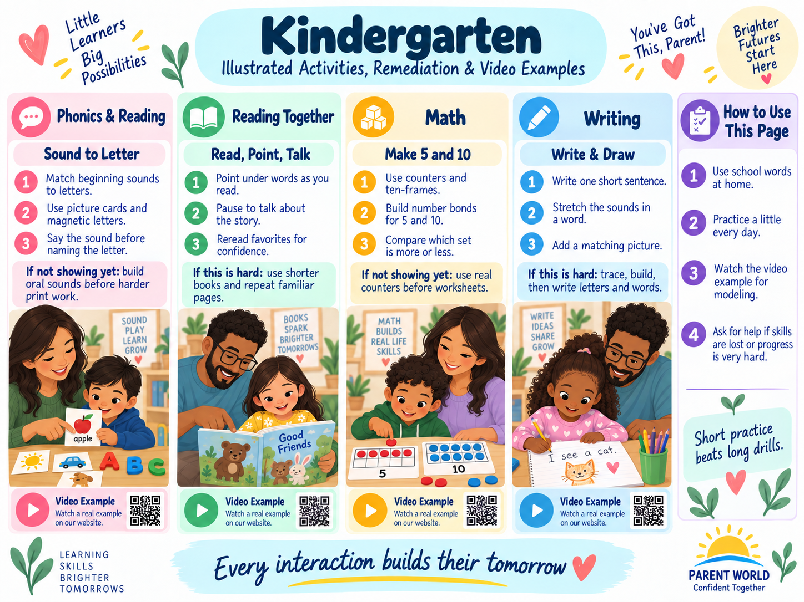
Kindergarten: visual examples for literacy, math, self-regulation, and home routines.
Big picture
Connect speech to print and quantities to symbols while learning classroom routines.

Choose only 1-2 priorities for this cycle
[ ] Letter-sound / phonemic awareness
[ ] Blending / beginner reading
[ ] Sentence meaning / emergent spelling
[ ] Counting / quantity
[ ] Addition-subtraction concepts
[ ] Help-seeking / routines
Primary priority  ________________________________________________ | Secondary priority  ________________________________________________
Cycle start date  ________________________________________________ | Review date  ________________________________________________
What would meaningful improvement look like?
What the teacher says is going well
What the teacher says should come next

Kindergarten: Weekly Home Plan
Day | Reading / language | Writing / spelling OR math | Independence / well-being
Mon | ________________ | ________________ | ________________
Tue | ________________ | ________________ | ________________
Wed | ________________ | ________________ | ________________
Thu | ________________ | ________________ | ________________
Fri | ________________ | ________________ | ________________
Weekend | ________________ | ________________ | ________________
A realistic routine
Try one shared reading block plus one brief targeted task on selected days. Stop or shorten when fatigue or frustration makes practice unproductive.

One home routine we are practicing independently

Kindergarten: Remediation Bridge

Remediation bridge: step back before pushing forward
Prerequisite to rebuild
preschool / Pre-K: oral language, sound play, small-quantity counting, purposeful drawing/writing, two-step routines and help-seeking. Kindergarten remediation should be concrete and explicit: hear/say it, touch/move it, connect it to a symbol, then practice briefly in connected work.

Activity | What the parent does | What improvement may look like
Hear it before you read it | Say a simple word such as map. Push one counter for each sound /m/ /a/ /p/. Then match the sounds to letters and blend them back together. | The child can hear/segment sounds and connect them to the letters rather than guessing from pictures.
One pattern, tiny word chain | Use letter tiles to build a taught pattern: map -> mat -> sat. Change one sound/letter at a time, then read a very short decodable sentence containing the pattern. | Accurate reading of new words with the taught pattern.
Build the number | Show a numeral 0-10 and build that quantity with counters or a ten-frame; reverse it by showing a set and choosing the numeral. | Reliable quantity-number matching rather than numeral naming alone.
Say it, draw it, write it | Child orally says one complete sentence, draws it, then writes as much as possible. Help stretch one difficult word into sounds; edit only one convention at a time. | A message another person can understand and increasing sound-based spelling.
School routine rehearsal | Practice a two-step school-like routine: open folder -> place paper inside; listen -> do -> check; or "I don't understand yet - can you show me the first step?" | Fewer reminders and more direct help-seeking.
Research basis: IES Foundational Skills K-3; IES Teaching Math to Young Children; IES Preparing Young Children for School; IES elementary writing guidance.
Do not wait on a real concern
If letter-sound learning, blending, speech/language, quantity understanding, attention to instruction, or school participation remains persistently difficult despite targeted teaching, ask the teacher what screening/intervention data show and what additional support is available.

Short practice log
Try | Activity / support | What I observed | Next change
1 | ____________________ | ____________________ | ____________________
For a longer cycle, use the reusable six-week tracker in the front of the workbook.

Kindergarten: School Partnership Page
[ ] What sound-spelling patterns are being taught now?
[ ] Can my child read new words with those patterns?
[ ] Can my child show what a number means with objects?
[ ] Can my child ask for help and follow a short routine?

Bring useful observations to the next conversation
Teacher / team member  ________________________________________________ | Date  ________________________________________________
Skill we are discussing  ________________________________________________ | Next review date  ________________________________________________
[ ] Ask: What can my child do independently right now?
[ ] Ask: What specific prerequisite is weak?
[ ] Ask: What strategy/language is being used at school so we can match it at home?
[ ] Ask: What evidence will show improvement?
[ ] Ask: When should we meet/review again?
Notes / agreed next steps

Kindergarten: Quarterly Dashboard
Area | Strength | Emerging skill | Evidence / example | Next step
Reading
Writing
Math
Knowledge / curiosity
Organization / independence
Social-emotional well-being
Child reflection: I am proud that... / I want help with...
Parent reflection: The support I should reduce or change next is...

Grade 1: Home Success Map
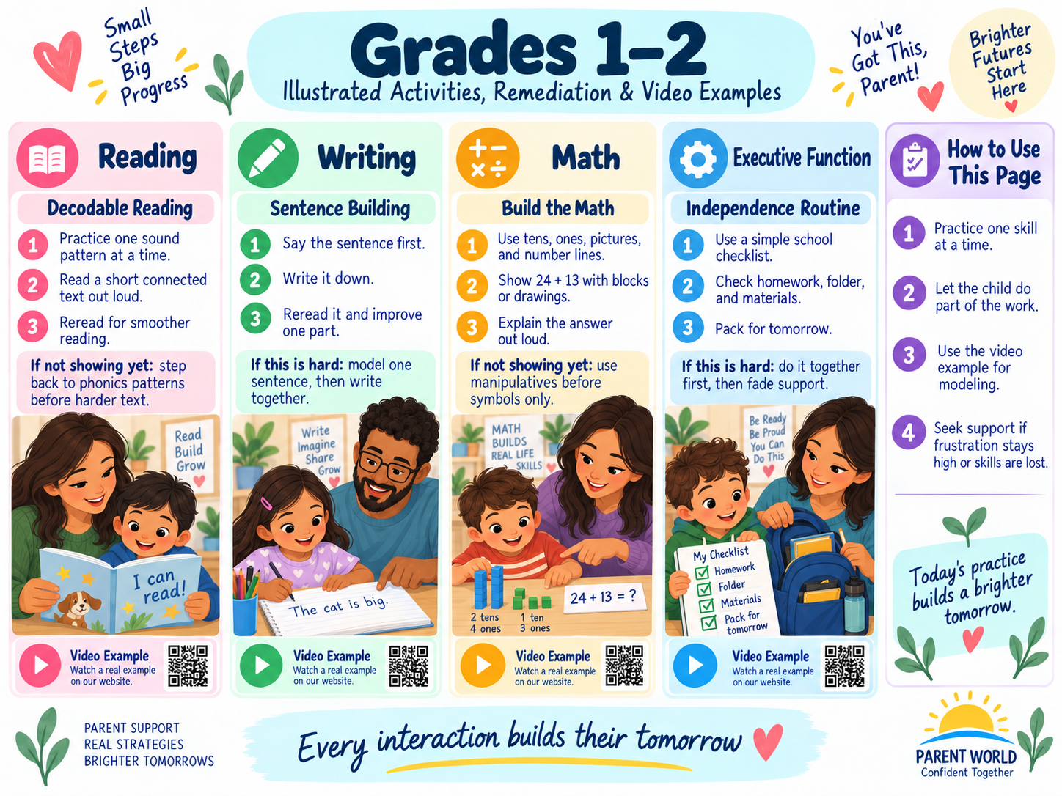
Grades 1–2: illustrated home-support examples for reading, writing, math, and independence.
Big picture
Build accurate reading/spelling, connected sentences, addition/subtraction reasoning, and simple independence.

Choose only 1-2 priorities for this cycle
[ ] Decoding / spelling patterns
[ ] Fluent meaningful reading
[ ] Connected sentences
[ ] Addition / subtraction within 20
[ ] Tens and ones
[ ] Task routines / friendship skills
Primary priority  ________________________________________________ | Secondary priority  ________________________________________________
Cycle start date  ________________________________________________ | Review date  ________________________________________________
What would meaningful improvement look like?
What the teacher says is going well
What the teacher says should come next

Grade 1: Weekly Home Plan
Day | Reading / language | Writing / spelling OR math | Independence / well-being
Mon | ________________ | ________________ | ________________
Tue | ________________ | ________________ | ________________
Wed | ________________ | ________________ | ________________
Thu | ________________ | ________________ | ________________
Fri | ________________ | ________________ | ________________
Weekend | ________________ | ________________ | ________________
A realistic routine
Try one shared reading block plus one brief targeted task on selected days. Stop or shorten when fatigue or frustration makes practice unproductive.

One home routine we are practicing independently

Grade 1: Remediation Bridge

Remediation bridge: step back before pushing forward
Prerequisite to rebuild
kindergarten: phoneme-letter connections, blending short words, quantities/add-subtract with objects, one-sentence messages, simple classroom routines. Use explicit modeling and concrete representations, then fade support. Keep rich read-alouds and conversation going even while foundational reading is rebuilt.

Activity | What the parent does | What improvement may look like
Sound-spelling reset | Review only the sound-spelling patterns the child has been taught. Build and read 5-8 words with tiles, then read a short connected text using those patterns. | The child decodes instead of memorizing/guessing and can transfer the pattern to a new word.
Stretch-spell-check | Say a short word, tap each sound, write the matching letters, then read the word back. Use 3-5 words, not a long spelling list. | More complete sound representation in spelling.
Make ten before memorizing | Use counters/ten-frames for facts such as 8+5: fill ten, then count the remainder. Record the equation after the model makes sense. | The child explains a strategy and gradually recalls related facts more efficiently.
One strong sentence | Orally rehearse who/what happened + one detail. Write it, then check just three things: capital, spaces, ending mark. | A complete understandable sentence with growing independence.
Read-do-check routine | Parent models how to read one direction, underline the action word, do only that step, then check it. Child repeats with a similar task. | Fewer impulsive starts and improved completion of simple directions.
Research basis: IES Foundational Skills K-3; IES elementary math intervention principles; IES writing practice guide; Harvard executive-function activities.
Do not wait on a real concern
Persistent difficulty connecting sounds and letters, blending, spelling sounds, understanding small quantities, or following classroom routines deserves a teacher conversation and targeted assessment - not simply more worksheets.

Short practice log
Try | Activity / support | What I observed | Next change
1 | ____________________ | ____________________ | ____________________
For a longer cycle, use the reusable six-week tracker in the front of the workbook.

Grade 1: School Partnership Page
[ ] Which reading patterns are secure vs still emerging?
[ ] Does spelling reflect the sounds in words?
[ ] Can my child explain a math strategy?
[ ] Can my child complete a short routine with fewer reminders?

Bring useful observations to the next conversation
Teacher / team member  ________________________________________________ | Date  ________________________________________________
Skill we are discussing  ________________________________________________ | Next review date  ________________________________________________
[ ] Ask: What can my child do independently right now?
[ ] Ask: What specific prerequisite is weak?
[ ] Ask: What strategy/language is being used at school so we can match it at home?
[ ] Ask: What evidence will show improvement?
[ ] Ask: When should we meet/review again?
Notes / agreed next steps

Grade 1: Quarterly Dashboard
Area | Strength | Emerging skill | Evidence / example | Next step
Reading
Writing
Math
Knowledge / curiosity
Organization / independence
Social-emotional well-being
Child reflection: I am proud that... / I want help with...
Parent reflection: The support I should reduce or change next is...

Grade 2: Home Success Map
Big picture
Turn accurate foundations into fluency, connected ideas, place-value reasoning, and stronger organization.

Choose only 1-2 priorities for this cycle
[ ] Reading fluency / word parts
[ ] Retell / main idea / evidence
[ ] Paragraphing / revision
[ ] Place value / regrouping
[ ] Measurement / time / money
[ ] Organization / flexible problem solving
Primary priority  ________________________________________________ | Secondary priority  ________________________________________________
Cycle start date  ________________________________________________ | Review date  ________________________________________________
What would meaningful improvement look like?
What the teacher says is going well
What the teacher says should come next

Grade 2: Weekly Home Plan
Day | Reading / language | Writing / spelling OR math | Independence / well-being
Mon | ________________ | ________________ | ________________
Tue | ________________ | ________________ | ________________
Wed | ________________ | ________________ | ________________
Thu | ________________ | ________________ | ________________
Fri | ________________ | ________________ | ________________
Weekend | ________________ | ________________ | ________________
A realistic routine
Try one shared reading block plus one brief targeted task on selected days. Stop or shorten when fatigue or frustration makes practice unproductive.

One home routine we are practicing independently

Grade 2: Remediation Bridge

Remediation bridge: step back before pushing forward
Prerequisite to rebuild
first grade: common sound-spelling patterns, accurate simple-text reading, place value in tens/ones, connected sentences, short independent routines. Second-grade support should restore accuracy and meaning first; fluency should grow from successful practice, not pressure for speed.

Activity | What the parent does | What improvement may look like
Pattern sort + connected reading | Sort a few teacher-aligned vowel/spelling patterns (for example, short vs. long vowel spellings), read each word, then read 3-5 sentences containing the pattern. | The child applies the pattern in new words and connected text.
Retell on three fingers | After a short passage, use first-next-last or beginning-middle-end on three fingers; then ask for one detail that proves the retell. | A coherent retell that preserves important events/ideas.
Build the tens and ones | Use bundled sticks/base-ten blocks/drawn tens and ones for addition or subtraction. Regroup physically first, then connect the action to written notation. | The child explains why 10 ones become 1 ten (or the reverse) instead of copying a rule.
Grow three sentences into a paragraph | Start with one main sentence. Add two details that answer who/what/where/how, then read all three aloud and add an ending if needed. | Related sentences stay on one topic and make sense in order.
Home-school organization reset | Use one folder location, one 3-item after-school checklist, and one "ask for help" sentence. Let the child check off the routine. | Fewer lost items and fewer adult verbal reminders over time.
Research basis: IES Foundational Skills K-3 and Reading Comprehension K-3; IES elementary math intervention; IES elementary writing guidance; spaced practice principles.
Do not wait on a real concern
If reading remains effortful, first identify whether the barrier is decoding, fluency, language/vocabulary, or comprehension. If math repeatedly breaks down, ask whether place value or operation meaning is secure. Coordinate targeted intervention with the school.

Short practice log
Try | Activity / support | What I observed | Next change
1 | ____________________ | ____________________ | ____________________
For a longer cycle, use the reusable six-week tracker in the front of the workbook.

Grade 2: School Partnership Page
[ ] Is reading effort coming from decoding, fluency, vocabulary, or comprehension?
[ ] Can my child keep related sentences on one topic?
[ ] Does regrouping make sense with tens and ones?
[ ] Can my child organize papers/materials with a repeatable routine?

Bring useful observations to the next conversation
Teacher / team member  ________________________________________________ | Date  ________________________________________________
Skill we are discussing  ________________________________________________ | Next review date  ________________________________________________
[ ] Ask: What can my child do independently right now?
[ ] Ask: What specific prerequisite is weak?
[ ] Ask: What strategy/language is being used at school so we can match it at home?
[ ] Ask: What evidence will show improvement?
[ ] Ask: When should we meet/review again?
Notes / agreed next steps

Grade 2: Quarterly Dashboard
Area | Strength | Emerging skill | Evidence / example | Next step
Reading
Writing
Math
Knowledge / curiosity
Organization / independence
Social-emotional well-being
Child reflection: I am proud that... / I want help with...
Parent reflection: The support I should reduce or change next is...

Grades 3 Through 5: Coach the Learner, Not Every Answer
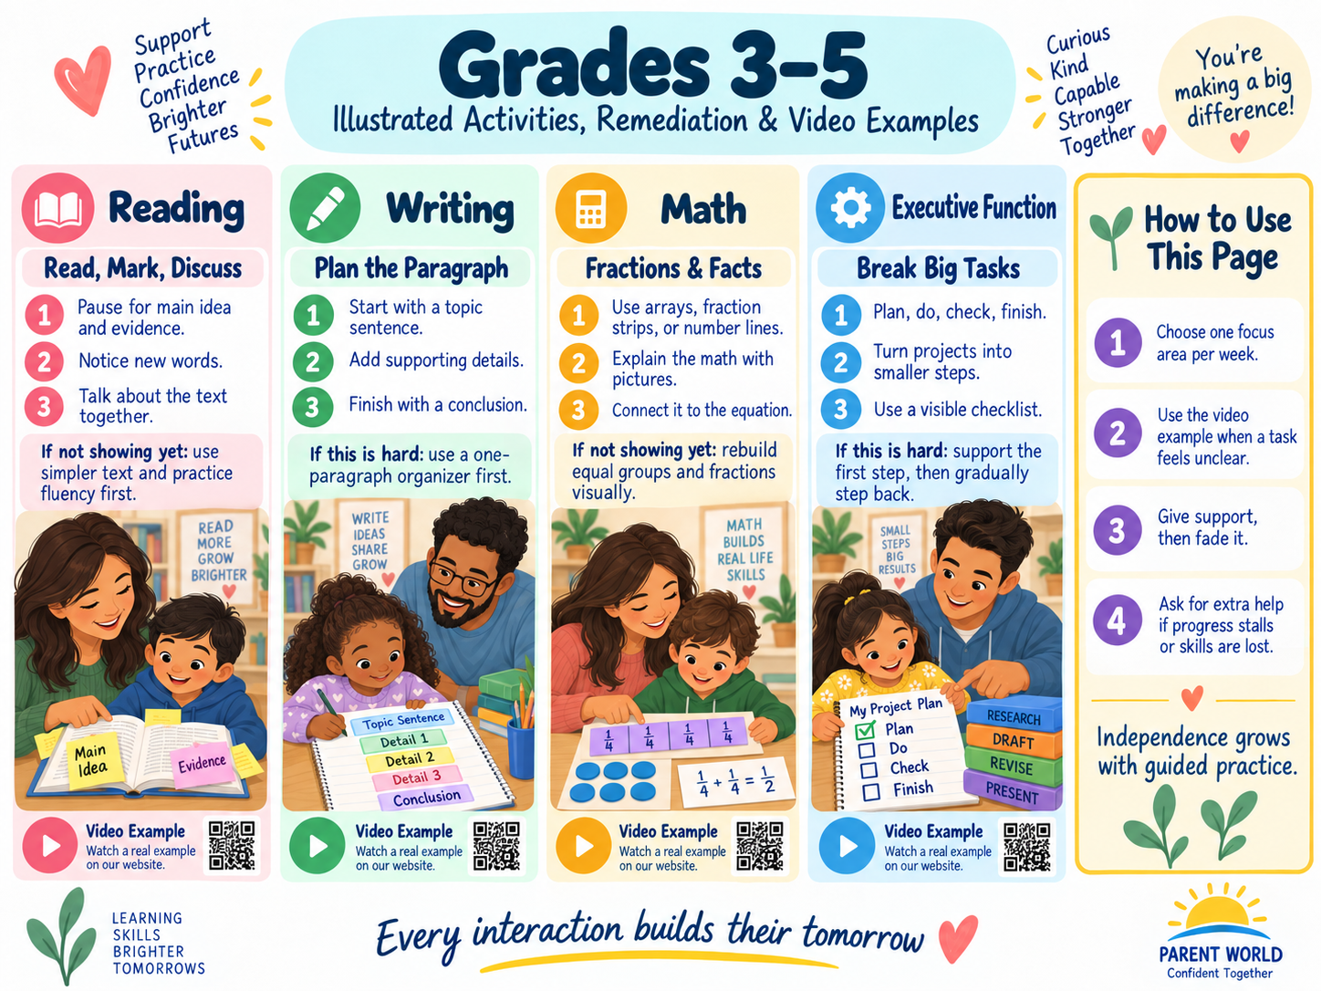
Grades 3–5: visual examples for reading, writing, math, executive function, and study habits.
Upper-elementary shift
The goal is increasing ownership: planning, evidence, multi-step reasoning, studying, self-advocacy, and recovering from mistakes. Parents still scaffold, but the support ladder should gradually move toward prompts, cues, waiting, and stepping back.

Grade 3: Home Success Map
Big picture
Evidence and multi-step reasoning become central. Foundational reading should still be addressed directly if it remains weak.

Choose only 1-2 priorities for this cycle
[ ] Word reading / morphology / fluency
[ ] Comprehension / evidence
[ ] Paragraph writing / revision
[ ] Multiplication / division
[ ] Fractions / area / perimeter
[ ] Projects / planning / help-seeking
Primary priority  ________________________________________________ | Secondary priority  ________________________________________________
Cycle start date  ________________________________________________ | Review date  ________________________________________________
What would meaningful improvement look like?
Current strength we can use as leverage
One task that repeatedly breaks down - what exactly happens?

Grade 3: Reading, Writing, and Knowledge Plan
Routine | This week | Evidence of growth
Independent / shared reading | ________________________ | ________________________
Vocabulary / word parts | ________________________ | ________________________
Evidence / summary / synthesis | ________________________ | ________________________
Writing / revision | ________________________ | ________________________
Science / history / general knowledge | ________________________ | ________________________
A topic the child wants to become an expert on

Grade 3: Math and Problem-Solving Plan
[ ] Start with meaning/model before speed.
[ ] Ask the child to estimate before calculating.
[ ] Use a drawing, number line, array, fraction model, or table when symbols become confusing.
[ ] Ask: "What does each number represent?"
[ ] Ask: "How could you check whether that answer is reasonable?"
Skill / unit | What makes sense | Where it breaks down | Representation / strategy to use next
Current computation
Current fraction/decimal work
Current word problems
Measurement / geometry / data

Grade 3: Remediation Bridge

Remediation bridge: step back before pushing forward
Prerequisite to rebuild
second grade: accurate word-pattern reading, coherent retell/main point, tens/ones and addition/subtraction meaning, focused groups of sentences, short independent routines. Third-grade gaps are easiest to address when the parent identifies the prerequisite skill rather than reteaching the entire grade. Keep grade-level knowledge available through read-aloud/audio/support while the targeted skill is rebuilt.

Activity | What the parent does | What improvement may look like
Word parts + reread | Take 5 longer words from current schoolwork. Mark syllables/prefixes/suffixes, read the parts, blend the word, explain its meaning, then reread the sentence. | More accurate multisyllabic decoding with less guessing.
One-paragraph main idea reset | Use a short paragraph. Ask: "Who/what is this mostly about?" "What is the most important thing about it?" Then choose 2 supporting details. | A concise main idea supported by relevant details.
Equal-groups bridge to multiplication | Build 3 groups of 4 counters, write 4+4+4 and 3x4, then rearrange as an array. Reverse with simple division stories. | The child explains what each factor/quotient represents rather than reciting facts only.
Paragraph frame, then remove it | Use topic sentence -> detail/evidence -> explanation -> closing. Write one paragraph together; next time cover one prompt and let the child supply that part. | Related ideas and growing independence from the frame.
Three-step assignment staircase | Write only three boxes: start, middle, finish. Estimate each, complete the first, check it, then continue. Gradually let the child create the boxes. | Less avoidance, better task initiation, and more accurate planning.
Research basis: IES Foundational Skills K-3; IES Reading Comprehension K-3; IES elementary math intervention; IES elementary writing; IES spacing/worked-example guidance.
Do not wait on a real concern
If the child understands read-alouds but cannot read comparable text independently, or foundational math/writing skills repeatedly block grade-level work, request targeted school assessment/intervention and a progress-review date.

Short practice log
Try | Activity / support | What I observed | Next change
1 | ____________________ | ____________________ | ____________________
For a longer cycle, use the reusable six-week tracker in the front of the workbook.

Grade 3: Independence and Well-Being Plan
Skill | Adult support now | Next level down the ladder
Starting work | ________________ | ________________
Planning a project | ________________ | ________________
Tracking materials | ________________ | ________________
Checking work | ________________ | ________________
Asking for help | ________________ | ________________
Handling frustration | ________________ | ________________
[ ] My child has a trusted adult at school.
[ ] My child can name at least one strategy for getting unstuck.
[ ] We talk about friendships/belonging, not only grades.
[ ] We protect sleep, movement, and downtime.
[ ] I give strategy/process feedback rather than labels about ability.

Grade 3: School Partnership and Quarterly Dashboard

Bring useful observations to the next conversation
Teacher / team member  ________________________________________________ | Date  ________________________________________________
Skill we are discussing  ________________________________________________ | Next review date  ________________________________________________
[ ] Ask: What can my child do independently right now?
[ ] Ask: What specific prerequisite is weak?
[ ] Ask: What strategy/language is being used at school so we can match it at home?
[ ] Ask: What evidence will show improvement?
[ ] Ask: When should we meet/review again?
Notes / agreed next steps
Area | Strength | Emerging | Next step
Reading / language
Writing / research
Math
Science / knowledge
Executive function
Social-emotional / self-advocacy
Child voice: What should adults keep doing? What should they stop doing for me?

Grade 4: Home Success Map
Big picture
The child coordinates information from several sources and manages longer tasks while fractions, multi-digit computation, and multiparagraph writing deepen.

Choose only 1-2 priorities for this cycle
[ ] Inference / text structure / sources
[ ] Multiparagraph writing
[ ] Multi-digit multiplication / division
[ ] Fractions / decimals
[ ] Research / knowledge building
[ ] Planning / digital judgment / peer skills
Primary priority  ________________________________________________ | Secondary priority  ________________________________________________
Cycle start date  ________________________________________________ | Review date  ________________________________________________
What would meaningful improvement look like?
Current strength we can use as leverage
One task that repeatedly breaks down - what exactly happens?

Grade 4: Reading, Writing, and Knowledge Plan
Routine | This week | Evidence of growth
Independent / shared reading | ________________________ | ________________________
Vocabulary / word parts | ________________________ | ________________________
Evidence / summary / synthesis | ________________________ | ________________________
Writing / revision | ________________________ | ________________________
Science / history / general knowledge | ________________________ | ________________________
A topic the child wants to become an expert on

Grade 4: Math and Problem-Solving Plan
[ ] Start with meaning/model before speed.
[ ] Ask the child to estimate before calculating.
[ ] Use a drawing, number line, array, fraction model, or table when symbols become confusing.
[ ] Ask: "What does each number represent?"
[ ] Ask: "How could you check whether that answer is reasonable?"
Skill / unit | What makes sense | Where it breaks down | Representation / strategy to use next
Current computation
Current fraction/decimal work
Current word problems
Measurement / geometry / data

Grade 4: Remediation Bridge

Remediation bridge: step back before pushing forward
Prerequisite to rebuild
third grade: multisyllabic decoding plus main idea/evidence, multiplication/division meaning, fractions on number lines, paragraph organization, visible multi-step plans. Fourth-grade intervention should preserve access to rich content while directly strengthening the prerequisite. IES guidance for grades 4-9 specifically supports decoding, purposeful fluency work, knowledge/vocabulary, questioning, gist, and comprehension monitoring.

Activity | What the parent does | What improvement may look like
Decode -> gist -> evidence | Use a short grade-appropriate paragraph. Decode 2-3 hard multisyllabic words explicitly, state the gist in one sentence, then point to evidence. | Improved word reading without losing comprehension.
Known facts to unknown facts | Use arrays or an area model to derive a harder fact from an easier one (6x7 = 5x7 + 1x7); connect a related division fact. | Flexible strategy use and stronger fact relationships.
Fraction number-line rebuild | Make equal-length paper strips for halves, fourths, eighths; place the fractions on a 0-1 number line and compare positions before doing symbolic rules. | Understanding that fractions are numbers with magnitude and equal-size parts.
Evidence paragraph chain | Write claim/topic -> evidence/detail -> "this shows…" explanation. Use one short source. Add transitions only after the reasoning is clear. | Evidence that directly supports the idea and an explanation of why it matters.
Plan-check-handoff | Parent models a 4-step assignment checklist once; next task, child fills the checklist with prompts; later, parent only asks "What is your first checkpoint?" | More independent planning and self-checking.
Research basis: IES Reading Interventions Grades 4-9; IES elementary math intervention; IES elementary writing; IES study/spacing guidance; Harvard executive-function activities.
Do not wait on a real concern
If basic decoding, fluency, arithmetic, fraction meaning, writing organization, or task management consumes so much effort that the child cannot demonstrate knowledge, collaborate with the school about intervention and accommodations rather than increasing homework volume.

Short practice log
Try | Activity / support | What I observed | Next change
1 | ____________________ | ____________________ | ____________________
For a longer cycle, use the reusable six-week tracker in the front of the workbook.

Grade 4: Independence and Well-Being Plan
Skill | Adult support now | Next level down the ladder
Starting work | ________________ | ________________
Planning a project | ________________ | ________________
Tracking materials | ________________ | ________________
Checking work | ________________ | ________________
Asking for help | ________________ | ________________
Handling frustration | ________________ | ________________
[ ] My child has a trusted adult at school.
[ ] My child can name at least one strategy for getting unstuck.
[ ] We talk about friendships/belonging, not only grades.
[ ] We protect sleep, movement, and downtime.
[ ] I give strategy/process feedback rather than labels about ability.

Grade 4: School Partnership and Quarterly Dashboard

Bring useful observations to the next conversation
Teacher / team member  ________________________________________________ | Date  ________________________________________________
Skill we are discussing  ________________________________________________ | Next review date  ________________________________________________
[ ] Ask: What can my child do independently right now?
[ ] Ask: What specific prerequisite is weak?
[ ] Ask: What strategy/language is being used at school so we can match it at home?
[ ] Ask: What evidence will show improvement?
[ ] Ask: When should we meet/review again?
Notes / agreed next steps
Area | Strength | Emerging | Next step
Reading / language
Writing / research
Math
Science / knowledge
Executive function
Social-emotional / self-advocacy
Child voice: What should adults keep doing? What should they stop doing for me?

Grade 5: Home Success Map
Big picture
The child synthesizes information and takes greater ownership while preparing for middle-school organization, study, and self-advocacy.

Choose only 1-2 priorities for this cycle
[ ] Multi-source synthesis / vocabulary
[ ] Evidence-based writing / research
[ ] Fractions / decimals / division
[ ] Volume / coordinates / expressions
[ ] Study / notes / long-term projects
[ ] Self-advocacy / middle-school readiness
Primary priority  ________________________________________________ | Secondary priority  ________________________________________________
Cycle start date  ________________________________________________ | Review date  ________________________________________________
What would meaningful improvement look like?
Current strength we can use as leverage
One task that repeatedly breaks down - what exactly happens?

Grade 5: Reading, Writing, and Knowledge Plan
Routine | This week | Evidence of growth
Independent / shared reading | ________________________ | ________________________
Vocabulary / word parts | ________________________ | ________________________
Evidence / summary / synthesis | ________________________ | ________________________
Writing / revision | ________________________ | ________________________
Science / history / general knowledge | ________________________ | ________________________
A topic the child wants to become an expert on

Grade 5: Math and Problem-Solving Plan
[ ] Start with meaning/model before speed.
[ ] Ask the child to estimate before calculating.
[ ] Use a drawing, number line, array, fraction model, or table when symbols become confusing.
[ ] Ask: "What does each number represent?"
[ ] Ask: "How could you check whether that answer is reasonable?"
Skill / unit | What makes sense | Where it breaks down | Representation / strategy to use next
Current computation
Current fraction/decimal work
Current word problems
Measurement / geometry / data

Grade 5: Remediation Bridge

Remediation bridge: step back before pushing forward
Prerequisite to rebuild
fourth grade: supported synthesis, multi-digit computation meaning, fraction equivalence/benchmark reasoning, organized multiparagraph writing, backward planning and self-checking. Fifth grade should not turn a prerequisite gap into a character judgment. Strengthen the missing foundation explicitly while continuing age-appropriate content, interests, friendships, and responsibilities.

Activity | What the parent does | What improvement may look like
Single-text synthesis before two texts | Take one paragraph/section: decode key words, write a 1-sentence gist, identify evidence, then add one inference. Only after this is stable compare a second source. | Accurate understanding of each source before synthesis.
Place-value model before algorithm | For multi-digit multiplication/division, use an area model or place-value sketch first; estimate, solve, then connect each partial product/quotient to the written algorithm. | The child can explain where each number comes from and judge reasonableness.
Equivalent-fraction reset | Use fraction strips/number lines to generate equivalent fractions and compare sizes; then add/subtract like denominators before unlike denominators. | The child understands the whole, equal parts, and equivalence instead of relying on cross-multiplication tricks.
Outline one section at a time | Plan a multi-paragraph piece as 3 boxes: purpose/introduction, 2-3 grouped ideas, conclusion. Draft one section, revise for clarity, then move on. | Paragraphs have distinct purposes and the child can explain the organization.
Weekly plan + self-advocacy rehearsal | Once a week, child lists deadlines, chooses first steps, predicts where help may be needed, and practices one specific teacher question. Parent checks the plan, not every task. | Earlier help-seeking and less dependence on parent reminders.
Research basis: IES Reading Interventions Grades 4-9; IES elementary math intervention; IES elementary writing; IES organizing instruction/study; Harvard executive-function activities for ages 7-12.
Do not wait on a real concern
Before the middle-school transition, persistent foundational gaps, substantial school avoidance/distress, or a mismatch between effort and performance should prompt a coordinated school conversation about assessment, intervention, accommodations, and review dates.

Short practice log
Try | Activity / support | What I observed | Next change
1 | ____________________ | ____________________ | ____________________
For a longer cycle, use the reusable six-week tracker in the front of the workbook.

Grade 5: Independence and Well-Being Plan
Skill | Adult support now | Next level down the ladder
Starting work | ________________ | ________________
Planning a project | ________________ | ________________
Tracking materials | ________________ | ________________
Checking work | ________________ | ________________
Asking for help | ________________ | ________________
Handling frustration | ________________ | ________________
[ ] My child has a trusted adult at school.
[ ] My child can name at least one strategy for getting unstuck.
[ ] We talk about friendships/belonging, not only grades.
[ ] We protect sleep, movement, and downtime.
[ ] I give strategy/process feedback rather than labels about ability.

Grade 5: School Partnership and Quarterly Dashboard

Bring useful observations to the next conversation
Teacher / team member  ________________________________________________ | Date  ________________________________________________
Skill we are discussing  ________________________________________________ | Next review date  ________________________________________________
[ ] Ask: What can my child do independently right now?
[ ] Ask: What specific prerequisite is weak?
[ ] Ask: What strategy/language is being used at school so we can match it at home?
[ ] Ask: What evidence will show improvement?
[ ] Ask: When should we meet/review again?
Notes / agreed next steps
Area | Strength | Emerging | Next step
Reading / language
Writing / research
Math
Science / knowledge
Executive function
Social-emotional / self-advocacy
Child voice: What should adults keep doing? What should they stop doing for me?

Reusable Tools: Copy or Reprint These Pages
Use only what solves a real problem
A workbook can become another burden if every page becomes a requirement. Reprint the pages that help your family; ignore the rest until they are useful.

Reusable Remediation Activity Log
Skill / concern  ________________________________________________ | Earlier prerequisite  ________________________________________________
Start date  ________________________________________________ | Review date  ________________________________________________
Try # | Activity / support used | What happened | What to change next
1 | ________________________ | ________________________ | ________________________
2 | ________________________ | ________________________ | ________________________
3 | ________________________ | ________________________ | ________________________
4 | ________________________ | ________________________ | ________________________
5 | ________________________ | ________________________ | ________________________
6 | ________________________ | ________________________ | ________________________
7 | ________________________ | ________________________ | ________________________
8 | ________________________ | ________________________ | ________________________
Decision: continue / advance / simplify / ask for help - and why

Family Reading Conference
Book / text  ________________________________________________ | Date  ________________________________________________
Who chose it?  ________________________________________________ | Read independently / together / aloud  ________________________________________________
[ ] Word reading was mostly accurate
[ ] Reading sounded phrased and meaningful
[ ] Child could explain the main idea / important events
[ ] Child supported an answer with the text
[ ] Child noticed a new word or idea
[ ] Text was enjoyable / interesting enough to continue
What did you notice, wonder, learn, or disagree with?
One next reading goal

Family Writing Conference
Piece / assignment  ________________________________________________ | Purpose  ________________________________________________
Audience  ________________________________________________ | Date  ________________________________________________
[ ] The main idea / purpose is clear.
[ ] Related ideas are grouped together.
[ ] Details or evidence actually support the point.
[ ] The order makes sense to a reader.
[ ] The child revised meaning before editing conventions.
[ ] The child can explain at least one revision they made.
Reader feedback: What is clear? What do I want to know more about?
One revision to make next

Math Error Analysis: Turn Mistakes into Information
Problem / skill  ________________________________________________ | Date  ________________________________________________
Unit / topic  ________________________________________________ | Was the answer reasonable?  ________________________________________________
[ ] Did I understand what the problem was asking?
[ ] Did I know what the numbers/units represented?
[ ] Did I choose a useful representation or strategy?
[ ] Did I make a computation error after choosing the right strategy?
[ ] Did I forget a prerequisite fact or concept?
[ ] Did I check the answer another way?
Draw / model / explain the problem a different way
The prerequisite I should practice is...

Backward Project Planner
Project  ________________________________________________ | Due date  ________________________________________________
What "done" looks like  ________________________________________________ | Adult check-in date  ________________________________________________
Step | Task | Target date | Done
1 | ________________________ | ____________ | [ ]
2 | ________________________ | ____________ | [ ]
3 | ________________________ | ____________ | [ ]
4 | ________________________ | ____________ | [ ]
5 | ________________________ | ____________ | [ ]
6 | ________________________ | ____________ | [ ]
What might get in the way? What is the backup plan?
What help should the child request - and from whom?

Study and Retrieval Planner
Studying is retrieving, not just rereading
Close the notes and try to recall, explain, solve, sketch, or answer. Then check what was missed and revisit it later.

Day | What to retrieve | How I will test myself | What I missed
Day 1 | ____________________ | ____________________ | ____________________
Day 2 | ____________________ | ____________________ | ____________________
Day 3 | ____________________ | ____________________ | ____________________
Day 4 | ____________________ | ____________________ | ____________________
Day 5 | ____________________ | ____________________ | ____________________
Day 6 | ____________________ | ____________________ | ____________________
Day 7 | ____________________ | ____________________ | ____________________
What I can now explain without looking

Help-Seeking and Self-Advocacy Practice
[ ] I can name the exact part that is confusing.
[ ] I can show what I already tried.
[ ] I can ask for the first step rather than asking someone to do it for me.
[ ] I know which adult can help with this problem.
[ ] I can ask about an accommodation/support respectfully.
Useful script
"I understand ______, but I am stuck on ______. I tried ______. Could you show me the first step / explain that part another way?"

A real situation where I could use this script

Parent-Teacher / Support-Team Meeting Prep
Date  ________________________________________________ | People attending  ________________________________________________
Main question  ________________________________________________ | Desired review date  ________________________________________________
[ ] Bring 2-3 dated work examples.
[ ] Describe what the child did independently vs with help.
[ ] Ask what prerequisite skill is missing, if any.
[ ] Ask what intervention/instruction is already happening.
[ ] Ask how progress is measured.
[ ] Ask what parents should practice - and what they should NOT add at home.
[ ] Agree on a follow-up date.
Meeting notes / decisions / responsibilities

Social Well-Being and Belonging Check-In
Date  ________________________________________________ | School / setting  ________________________________________________
Person checking in  ________________________________________________ | Child mood today  ________________________________________________
[ ] I feel safe at school / program.
[ ] I have someone I can talk to.
[ ] I have at least one person I enjoy being with.
[ ] I know what to do when someone is unkind.
[ ] I can make a mistake without feeling like I am a failure.
[ ] Schoolwork leaves room for sleep, movement, play/interests, and family connection.
Child voice - what is going well socially or emotionally?
What needs adult attention rather than asking the child to handle it alone?

End-of-Year / Transition Planner
Current stage / grade  ________________________________________________ | Next stage / grade  ________________________________________________
Transition date  ________________________________________________ | School / program  ________________________________________________
Carry forward | Why it matters | How we will maintain it
Reading / language strength
Math / reasoning strength
Organization routine
Self-advocacy skill
Friendship / belonging support
Interest / hobby / identity strength
One prerequisite to strengthen before the transition
One adult support to reduce so the child can own more
One support/accommodation that should continue

Family Reflection: Confident Together
Success is bigger than a score
Growth includes skill, independence, curiosity, belonging, persistence, help-seeking, and knowing how to recover when something is hard.

Child: Something I can do now that used to be hard
Parent: Something I learned about how my child learns
Something we want to keep doing as a family
Something we are ready to stop, simplify, or hand over
The role changes. The relationship remains.

Research and Safety Notes
[ ] This workbook is a companion to Parent World, Confident Together: A Comprehensive Birth To 5th Grade and uses the same evidence base.
[ ] Birth-to-three checkpoint pages align with CDC developmental monitoring and the comprehensive guide's stage-specific remediation bridges.
[ ] Academic remediation follows the guide's evidence-based principle of rebuilding prerequisites with explicit modeling, concrete/visual representations, connected practice, and gradually reduced adult support.
[ ] Executive-function pages use modeling, external supports, short practice, retrieval, planning, and progressive transfer of responsibility.
[ ] Local school/state expectations vary. Align academic goals and terminology with the child's actual curriculum and teacher guidance.
[ ] Home practice is not a substitute for developmental screening, specialized instruction, disability evaluation, medical care, speech/language services, occupational/physical therapy, or mental-health support when those are indicated.
Act early when the pattern matters
For young children, loss of skills or persistent developmental concern warrants prompt professional discussion. For school-age children, persistent skill gaps, substantial distress, school avoidance, bullying, or a mismatch between effort and performance should be brought to the school team and, when appropriate, a healthcare professional.

For full citations, source links, evidence-strength notes, and developmental/academic explanations, use the Research and Reference Directory in the comprehensive Parent World guide.

